# Your brain

## 2.1

X = π

## 2.2

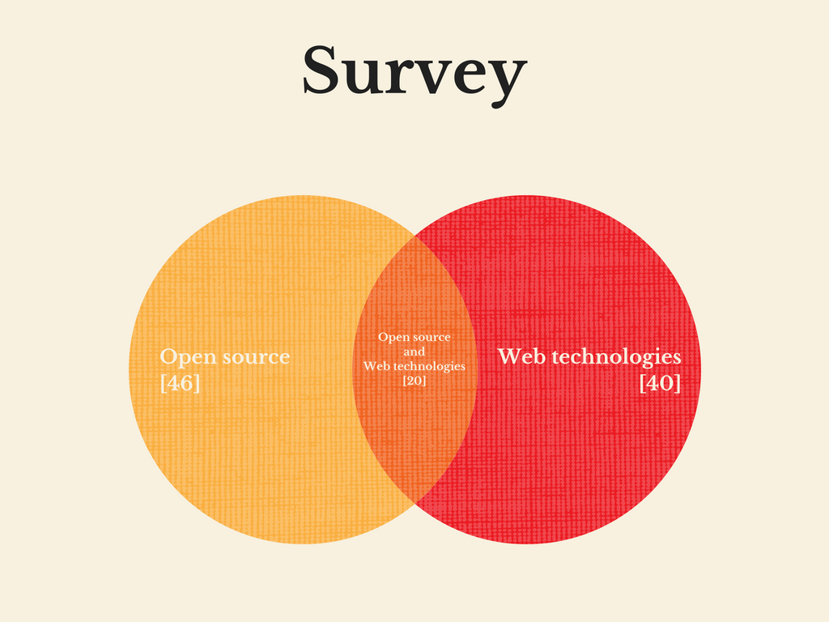

## 2.3

|  |  |  |  |  |  |
| --- | --- | --- | --- | --- | --- |
|  | Ana | Bob | Charlie | Diana | Ebbe |
| Language | C# | JavaScript | Python | SQL | Java |
| Floor | 2 | 1 | 3 | 4 | 5 |